LAB 6 — Resilient Internet + Secure Microservices (Optional)
Member

นายธนดล ไชยศิลา | 673380585-0
นางสาวกัญญาภัค ทองวิเศษ | 673380391-3
นางสาวนันทพร ลุนทอง | 673380409-0
นางสาวอลิชา ชนะบุญ | 673380431-7
นางสาวปรายฝน ฮกเซ็ง | 673380591-5
นางสาวปวริศา สีดาชมภู | 673380592-3

LAB 6 Topology Evolution
Same physical layout as Lab 5:

Internet
|
R1 G0/0 (NAT Edge)
|
R1 S0/0/0 ---- R2 S0/0/0 (100.10.10.0/30)
| |
LAN A LAN B

But now we introduce:

- OSPF Area 0 between R1 and R2
- IP SLA tracking default route
- ACL filtering WAN
- Controlled microservice exposure

ผลลัพธ์ :

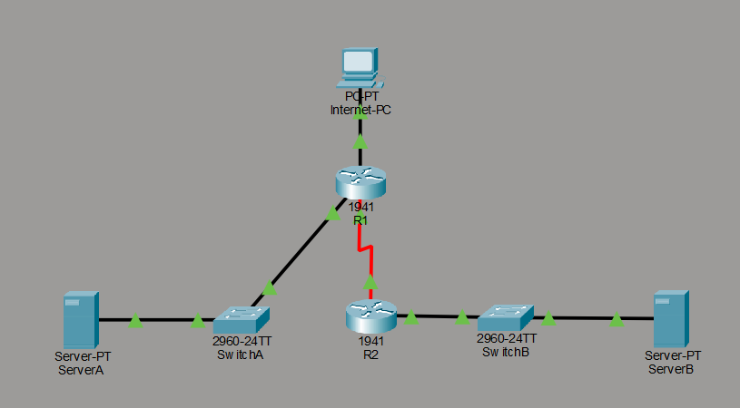

PHASE 1 — Replace Static with OSPF

Why?
Static routes:

- No failover intelligence
- No topology awareness
- No scalability

OSPF provides:

- Automatic route exchange
- Convergence
- Metric-based path selection

🔹 R1 OSPF
router ospf 1
router-id 1.1.1.1
network 100.10.10.0 0.0.0.3 area 0
network 192.168.10.0 0.0.0.255 area 0
passive-interface g0/1

ผลลัพธ์ :
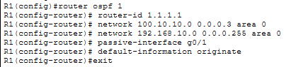

🔹 R2 OSPF
router ospf 1
router-id 2.2.2.2
network 100.10.10.0 0.0.0.3 area 0
network 192.168.20.0 0.0.0.255 area 0
passive-interface g0/1

ผลลัพธ์ :
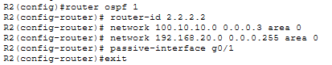

🔹 Default Route Injection from R1
router ospf 1
default-information originate

Now:

- R2 automatically learns default route
- No static route needed

ผลลัพธ์ :

PHASE 2 — WAN Failure Detection (IP SLA)
We simulate real ISP outage detection.

On R1
ip sla 1
icmp-echo 8.8.8.8 source-interface g0/0
frequency 5
exit

ip sla schedule 1 life forever start-time now

track 1 ip sla 1 reachability

ip route 0.0.0.0 0.0.0.0 g0/0 track 1

If Internet fails:

- Default route removed
- OSPF stops advertising it
- R2 loses default cleanly

This mimics enterprise edge behavior.

ผลลัพธ์ :
เนื่องจากใน Cisco Packet Tracer ไม่รองรับการทดสอบ IP SLA จึงขออนุญาติข้ามขั้นตอนดังกล่าว

PHASE 3 — Basic WAN Security
Currently: WAN is fully open.

We harden it.

Block unsolicited WAN inbound
On R1:

ip access-list extended WAN-IN
permit tcp 192.168.20.0 0.0.0.255 192.168.10.0 0.0.0.255
deny ip any any log

interface s0/0/0
ip access-group WAN-IN in

Now:

- Only LAN B → LAN A allowed
- All other WAN inbound blocked
- Logged for visibility

ผลลัพธ์ :
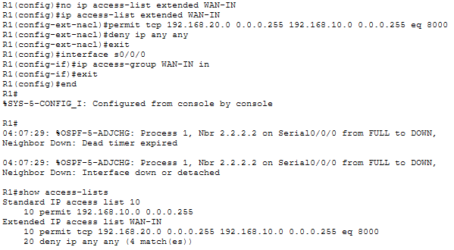

PHASE 4 — Microservice Exposure Control
Instead of exposing entire server:

Expose only gateway service.

Example:

ip nat inside source static tcp 192.168.10.10 8000 interface g0/0 8000

Now:

- Only port 8000 reachable from Internet
- Backend services remain private

This models:

- API Gateway pattern
- Real production practice

ผลลัพธ์ :
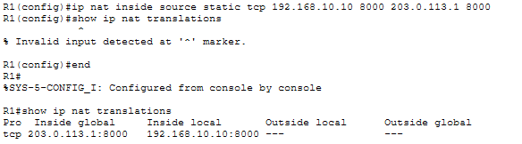

PHASE 5 — Observability Foundation
Add:

On Routers:
service timestamps log datetime msec
logging buffered 4096

ผลลัพธ์ :
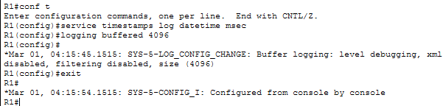
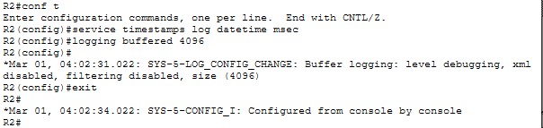

Enable NetFlow (optional advanced)
ip flow-export version 9


PHASE 6 — Microservice Network Validation
Now validate:

Test 1
ClientA → ServerB via OSPF path

Test 2
R2 loses default if ISP unreachable

Test 3
Internet cannot access backend ports

Test 4
Gateway reachable from Internet

LAB 6 Test Plan
Test | Expected Result
OSPF neighbor | FULL
show ip route ospf | Remote LAN visible
ISP unplug | Default route disappears
Internet → port 8000 | Success
Internet → port 9000 | Blocked
LAN A ↔ LAN B | Success

Test 1 — Ping LAN A ↔ LAN B :

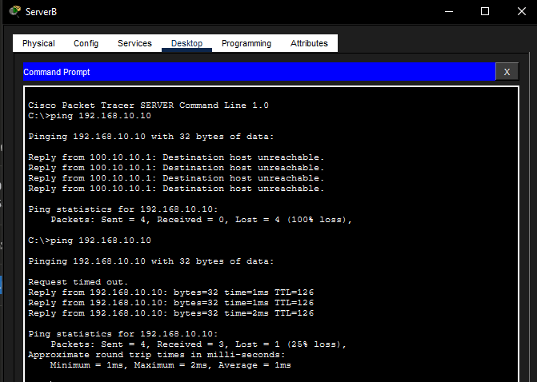

Test 2 — Internet-PC ping หา ServerA :
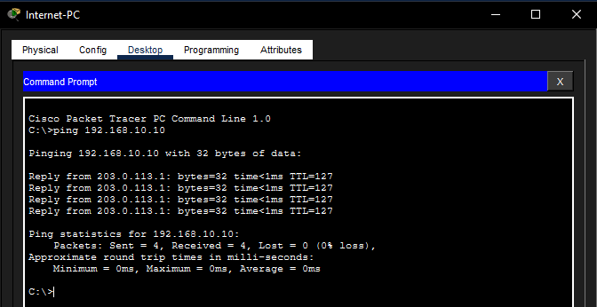

Test 3 — ทดสอบ NAT Port 8000 :
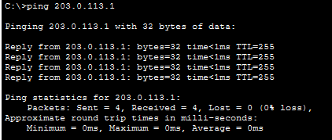
Test 4 — ทดสอบ port 9000 ถูกบล็อก
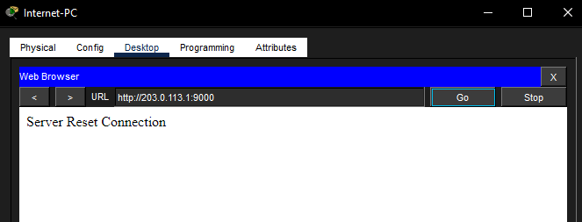

Readiness Score After LAB 6
Category | Score
Routing | 9/10
WAN Intelligence | 9/10
Security | 6/10
Microservice Exposure | 8/10
Scalability | 8/10

